**R Code for Examples in the book**

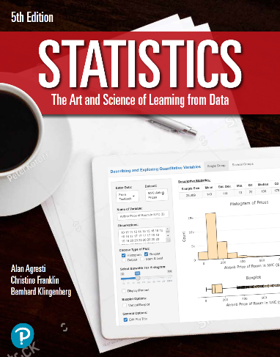

***“Statistics: The Art and Science of Learning from Data”***

**by Agresti, Franklin and Klingenberg, 5th edition**

**Chapter 8**

**Example 5: Exit Poll – Choosing a Sample Size**

## Reading in sample proportion data

phat <- 0.58

## Setting 95% confidence level

zscore = qnorm(0.975)

## Setting the margin of error to what we need

me <- 0.04

## To compute the number of samples required to acquire our wanted margin of error

n <- (zscore ** 2) * phat * (1 - phat) / (me ** 2)  
round(n)

## [1] 585